RING-A-DING-DING! HO! HO! HO!

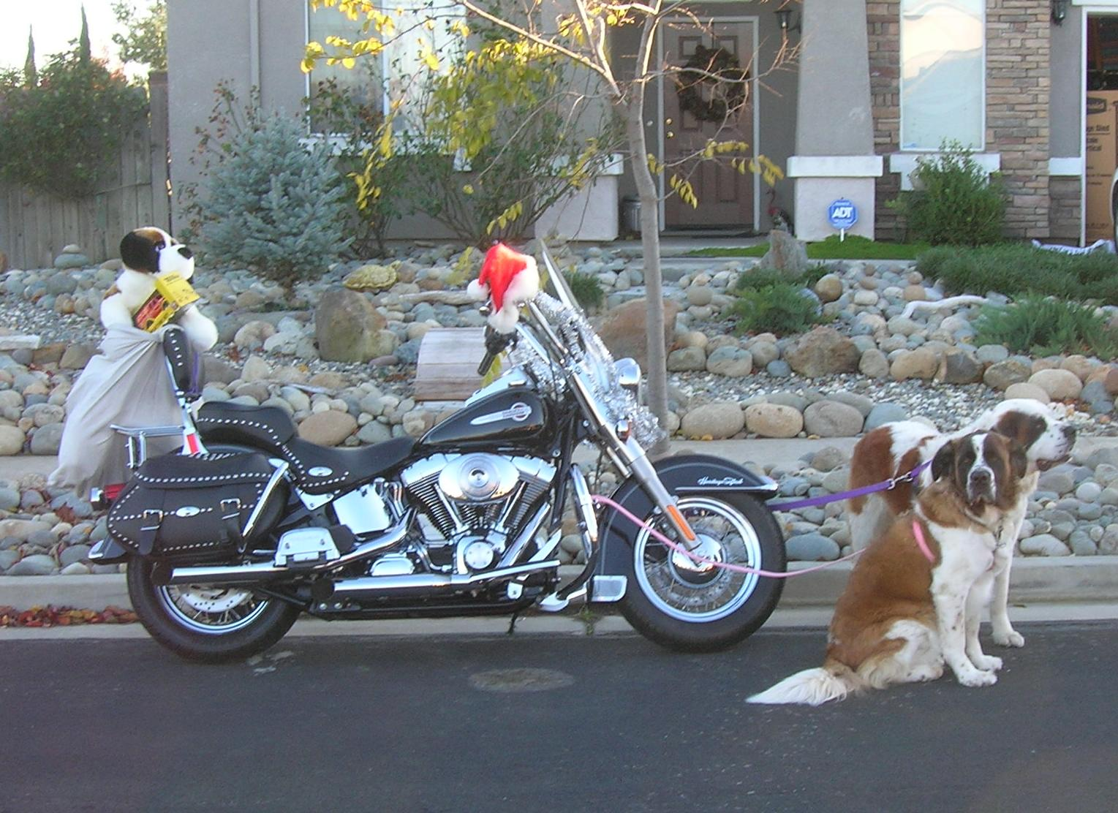  "...I don wanna be a reindeer..."  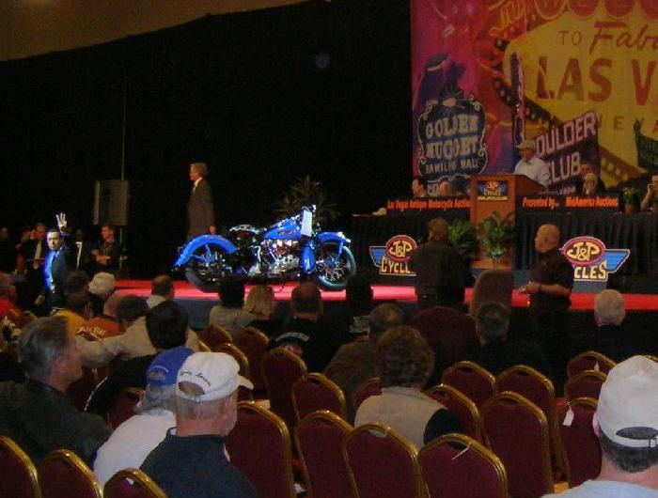  Knuck at auction  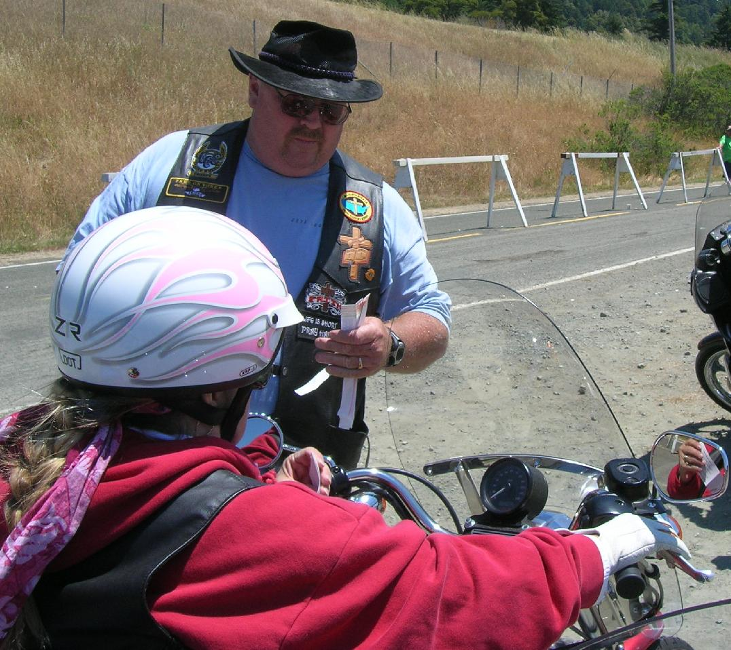  Sharon getting wristband at River View Ranch  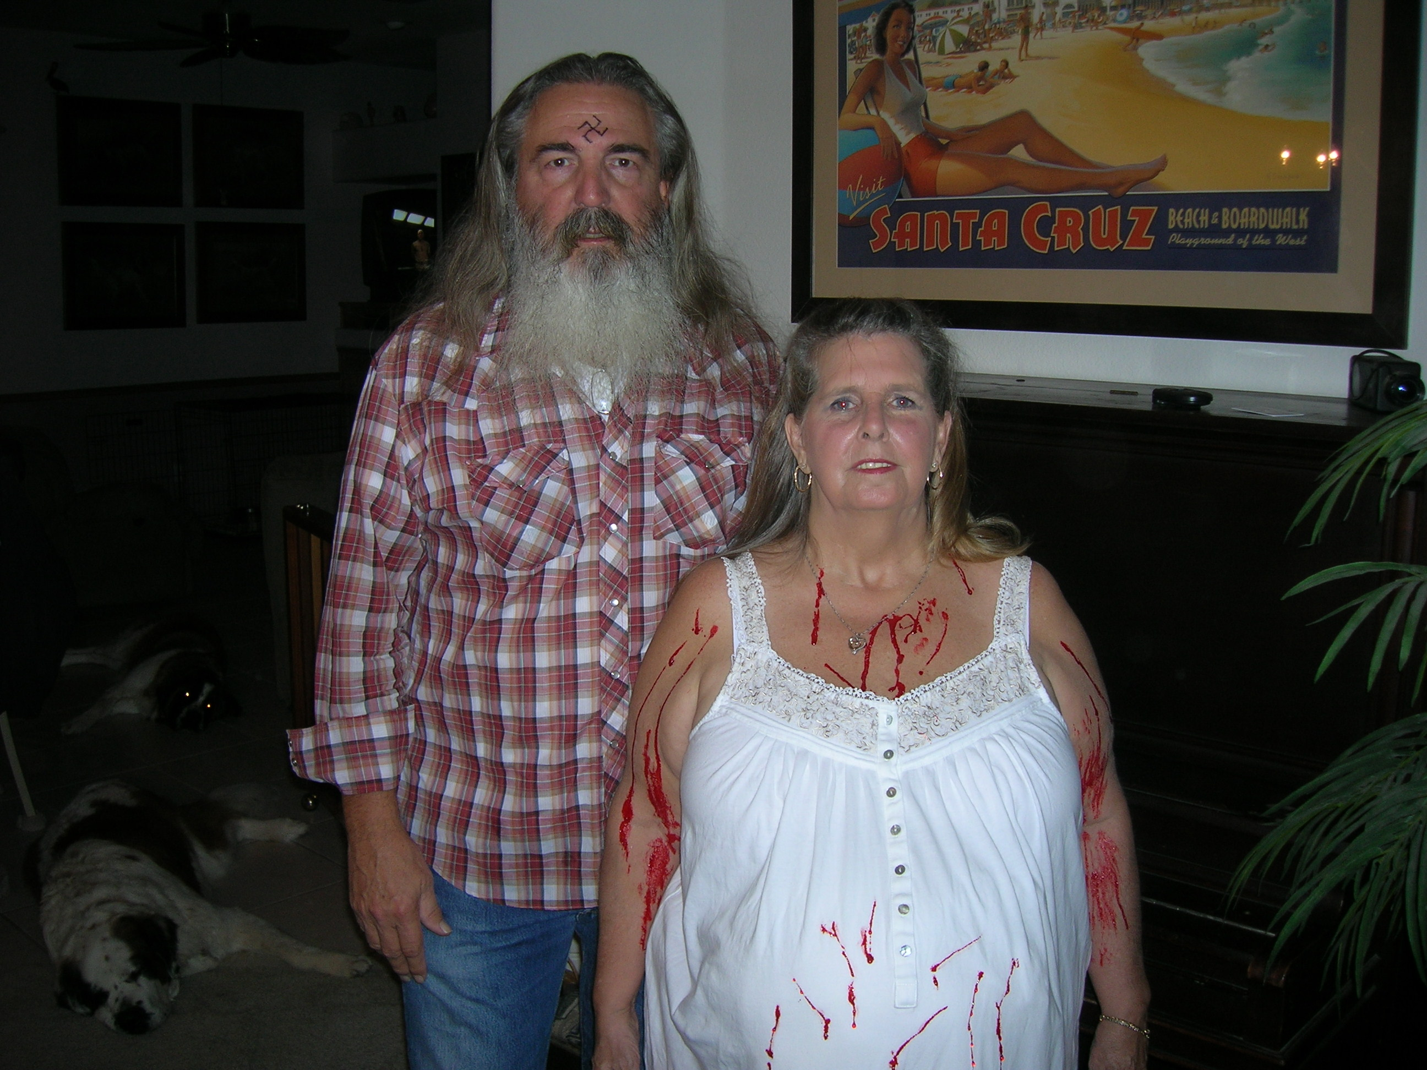  Charles Manson and Sharon Tate | Bernie is now a 60 year old puppy, lumpy sometimes, but still playful. She still gets in the pool whenever she wants no matter what the temperature is outside. Izzy is still the very barky protective 25 year old running laps around the pool.  We started 2009 off with a trip to Las Vegas for the Eighteenth Annual Las Vegas MidAmericaAntique Motorcycle Auction 8,9,10JAN09 THE ERA IS GONE FOREVER... FORTUNATELY THE MOTORCYCLES REMAIN.... unfortunately a little more than I was willing to pay... for now.... more pics at rivercityharleyriders.com and follow the links to special events to…  March - we adopted Dave... long time riding partner... now Rusl has a playmate and someone to share the chores, not to mention Dave has spoiled the puppies more than ever.  Oh! Also we got a gold fish named Lucky. We had to wait until she survived 5 months before we got her a real tank.  32nd Annual Redwood Run 11-14JUN09 Riverview Ranch, Piercy, CA - The ultimate biker party, and, Sharon rode her own bike this year! This event continues to remain an outstanding biker party! I even got a patch to prove it! more pics at rivercityharleyriders.com and follow the links to special events to...  Sacramento HOG Chapter #295 riders have formed a new NPO, River City Harley Riders Association (rivercityharleyriders.com), for which I remain/am the webmaster and Sharon is the newsletter editor.  Sharon and I went to the E. Clampus Vitus Outpost 1841 (more playmates for Rusl) Halloween Bash as Charles Manson and Sharon Tate... more pics at www.ecv1841.com... I am also the webmaster for this organization.  Grants Pass Ride 11-13SEP09 – Rusl and Dave ride up, only 4 of us left; Sharon stayed home and relaxed, see more pics at rivercityharleyriders.com and follow the links to special events to... | 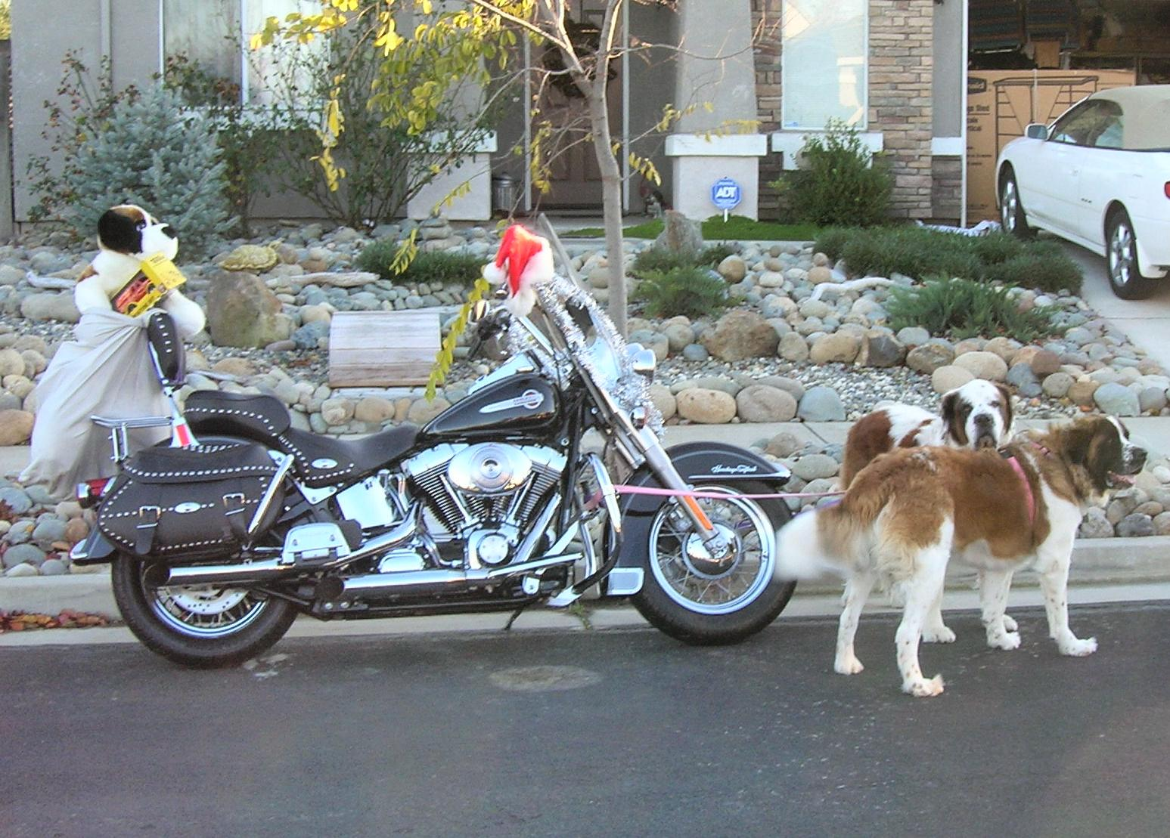  "You fooled Izzy but I'm not pullin' this hog."  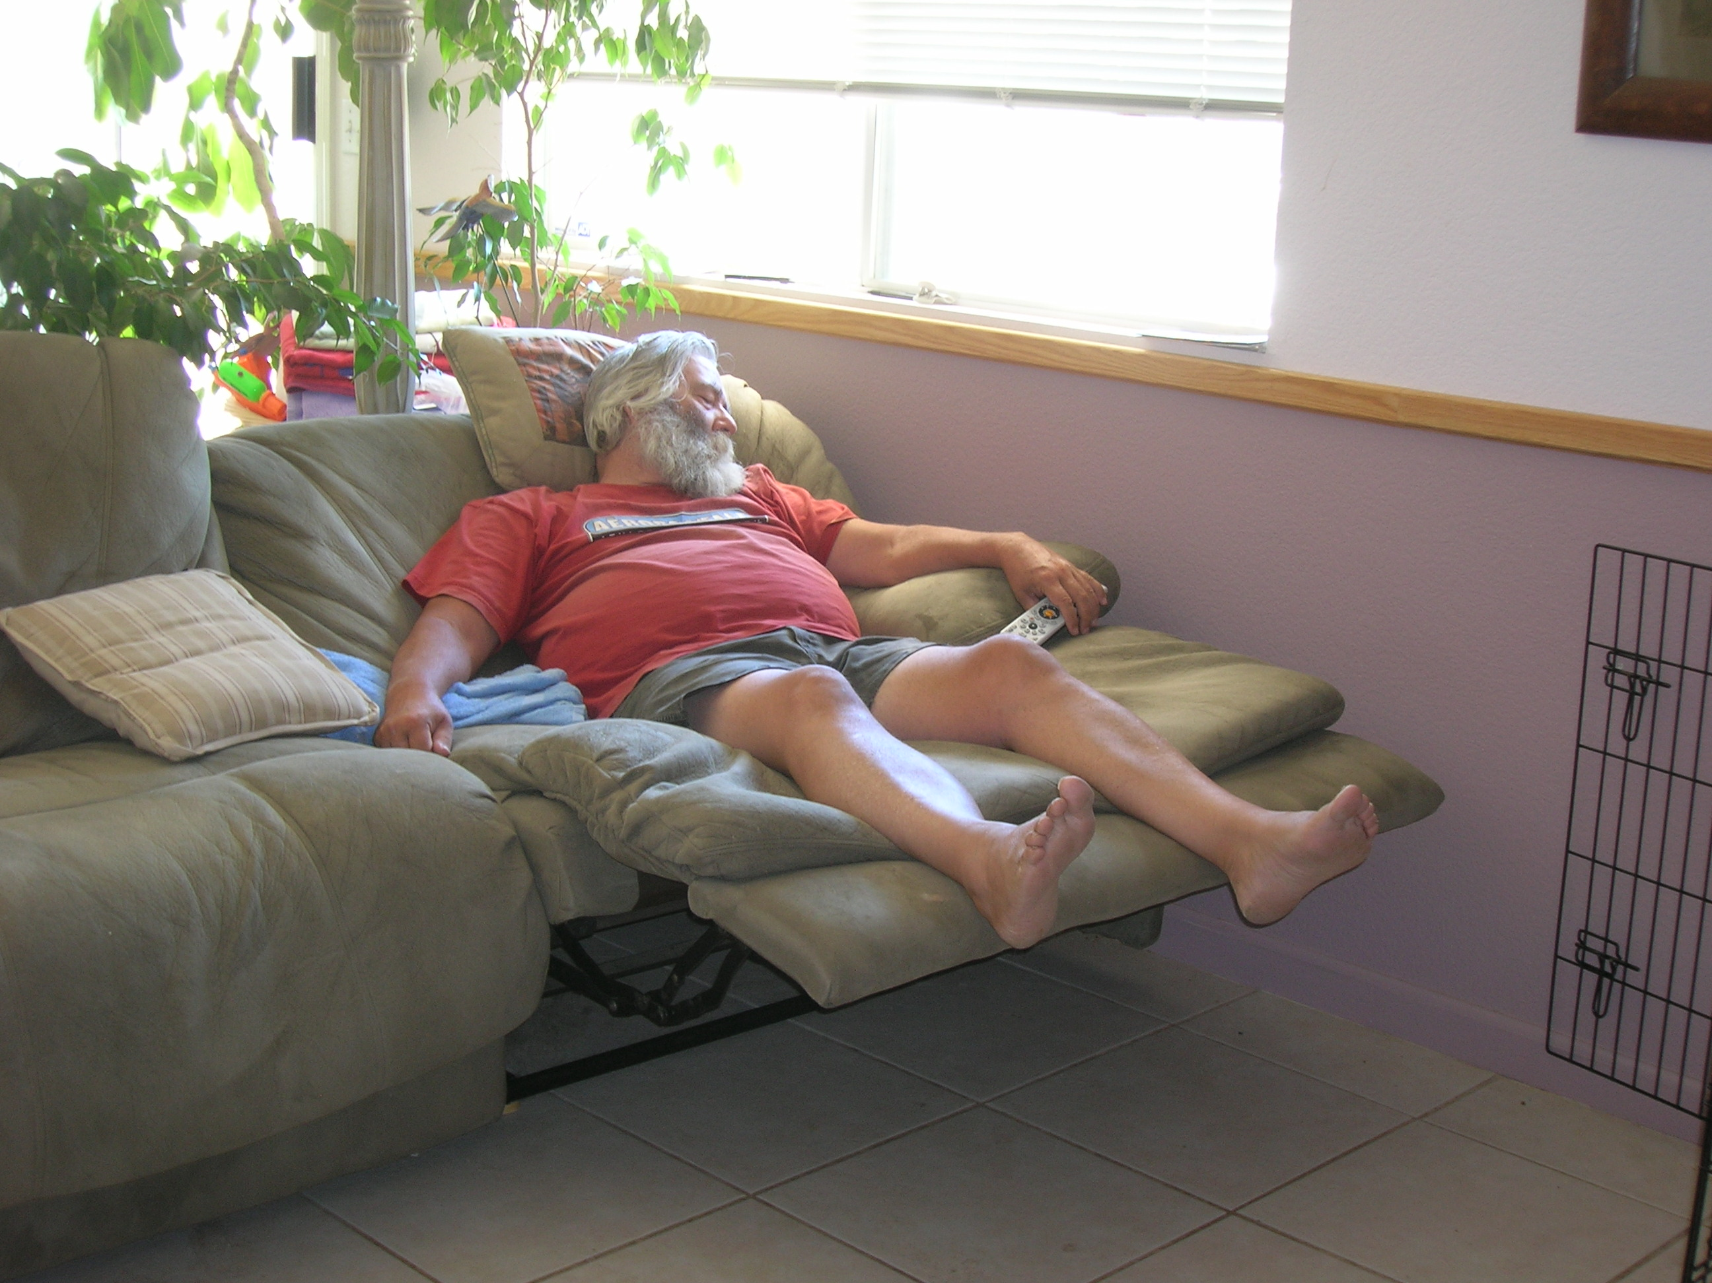Dave's not here man...  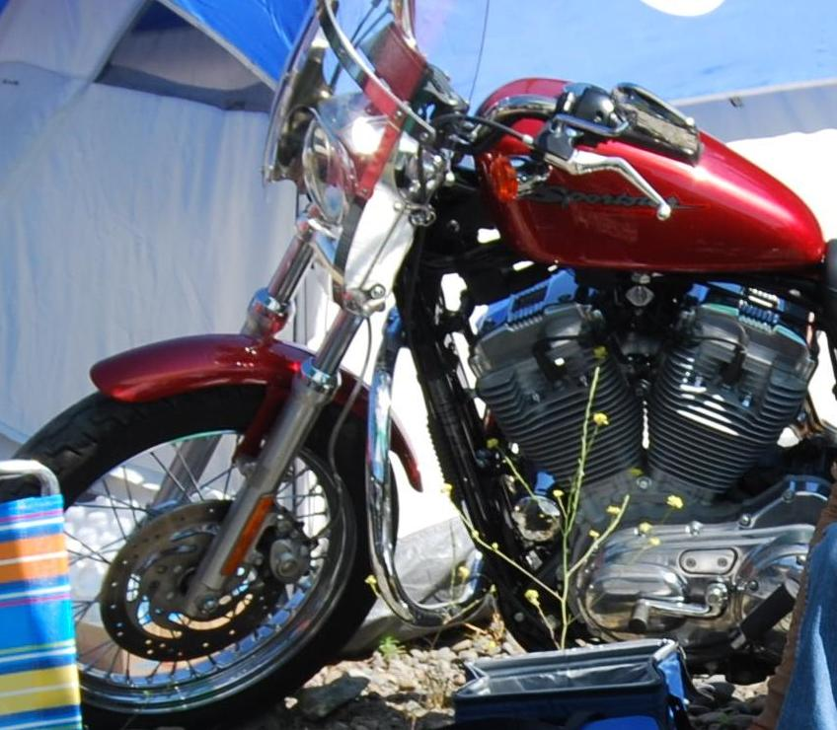Sharon’s XL883 in camp on the Redwood Run  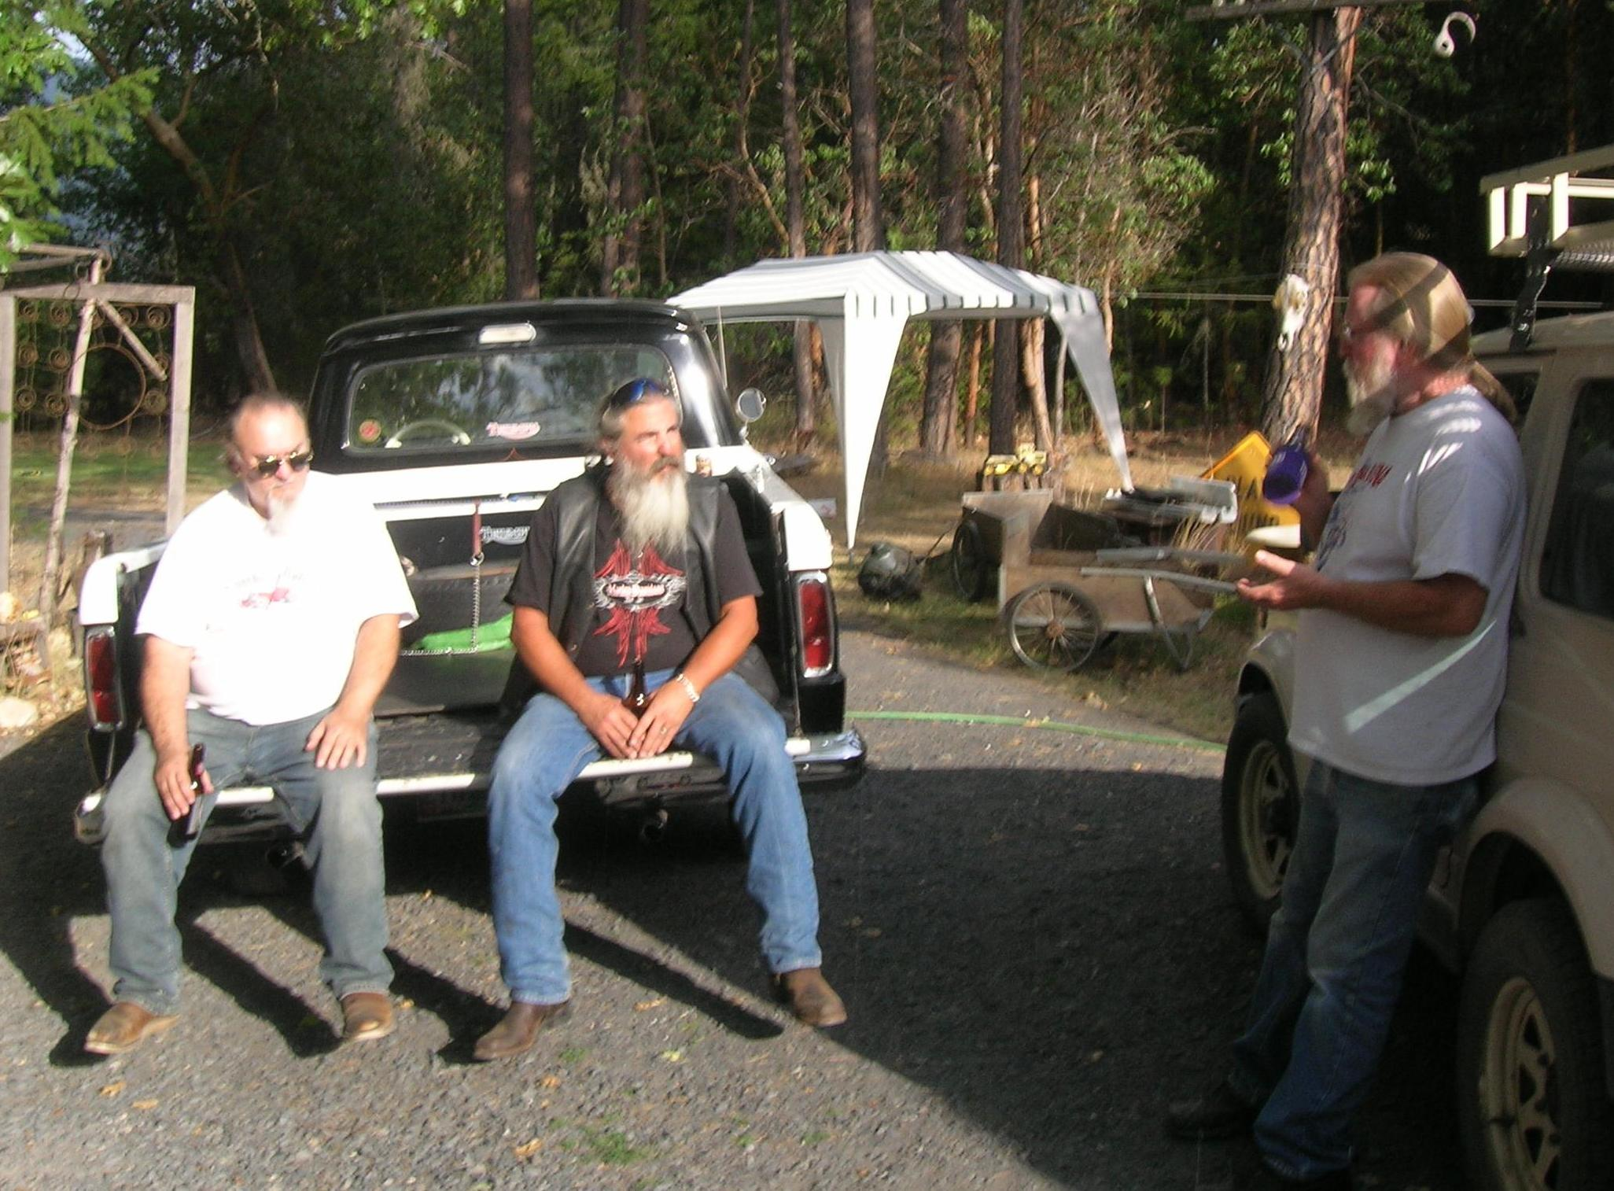  Joe, Raz and Moe at Moe's place

Quiet Thanksgiving and equally quiet Christmas expected. We are still waiting for the winning lottery ticket and Rusl's retirement has been pushed to at least 66 - more money per month if he waits.

We wish everyone a Very Merry Christmas and a Very Happy New Year!
Sharon, Raz, Bernie, Izzy, Dave, Lucky

