Russell, you're staying here in 38 days! Counting down...
Do you want to cancel, make changes or contact the property?

Howard Johnson Express Oklahoma City 3 stars
400 South Meridian Avenue, Oklahoma City, OK 73108 , USA – Show map

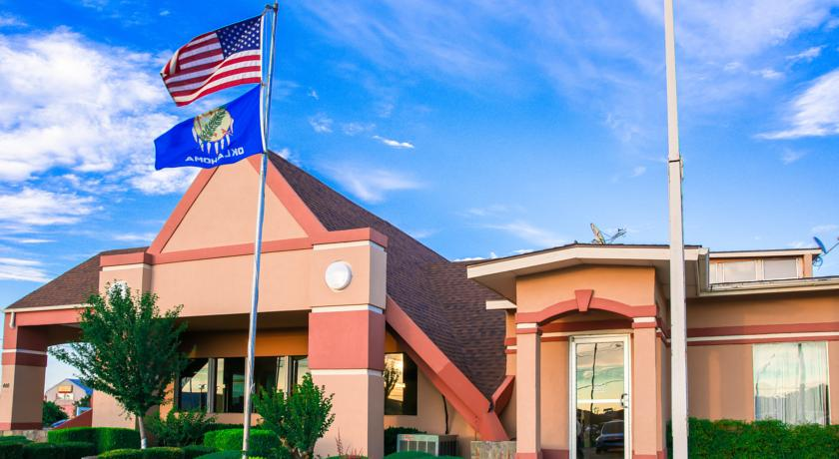
Very good 8.1/10 Score from 647 reviews

Motel Howard Johnson Express Oklahoma City sells fast on our site. Conveniently located off Interstate 40, this hotel offers free Wi-Fi in every room. A continental breakfast is served each morning.
Rooms at the Oklahoma City Howard Johnson Express include cable TV, a microwave and a fridge. A hairdryer is also provided.
This Howard Johnson Express is a 5 minute drive from downtown Oklahoma City, Will Rogers World Airport, Myriad Convention Center, Oklahoma City Zoo, and Frontier City.
Looking for staff who speak English? Then this property is a good choice for you.
This property has been on Booking.com since Aug 18, 2008.
Motel: 96 rooms , Hotel Chain: Howard Johnson

