Russell, you're staying here in 37 days! Counting down...
Do you want to cancel, make changes or contact the property?

Howard Johnson Albuquerque Midtown 3-star hotel
900 Medical Arts Northeast, Albuquerque, NM 87102, USA – Show map
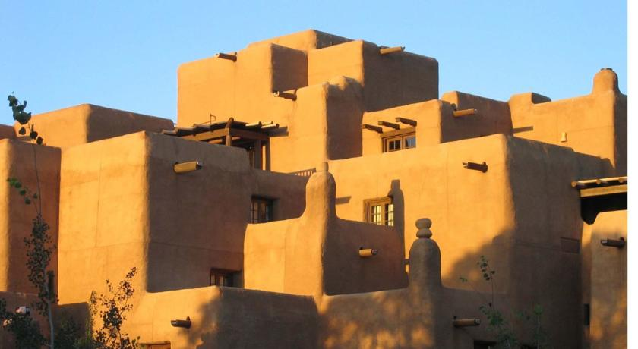
Very good 8/10 Score from 374 reviews
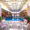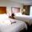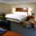
Hotel Howard Johnson Albuquerque Midtown sells fast on our site. Located 3 miles from Albuquerque International Airport, this Albuquerque hotel offers a free airport transfer service and an indoor pool. Free Wi-Fi and a daily hot breakfast are included.
A microwave, small refrigerator and a seating area with cable TV and work desk are provided in each room at Howard Johnson Albuquerque Midtown. A coffee machine and hairdryer are also included.
Guests can relax on the sun terrace or in the indoor hot tub. On-site recreational activities include a basketball court, fitness centre and game room.
The University of New Mexico is less than one mile from Howard Johnson Albuquerque Midtown. Balloon Fiesta Park is 8 miles away.
Looking for staff who speak English? Then this property is a good choice for you.
This property has been on Booking.com since Mar 18, 2011.
Hotel Rooms: 120, Hotel Chain: Wyndham Hotels & Resorts

